Project Design Phase-I
Solution Architecture

Date | 16 October 2026
Team ID | Roll 58
Project Name | EV Market Project design
Maximum Marks | 4 Marks

Solution Architecture:
Solution architecture is a complex process – with many sub-processes – that bridges the gap between business problems and technology solutions. Its goals are to:
- Find the best tech solution to solve existing business problems.
- Describe the structure, characteristics, behaviour, and other aspects of the software to project stakeholders.
- Define features, development phases, and solution requirements.
- Provide specifications according to which the solution is defined, managed, and delivered.

Solution Architecture Diagram — EV Market Analysis Dashboard
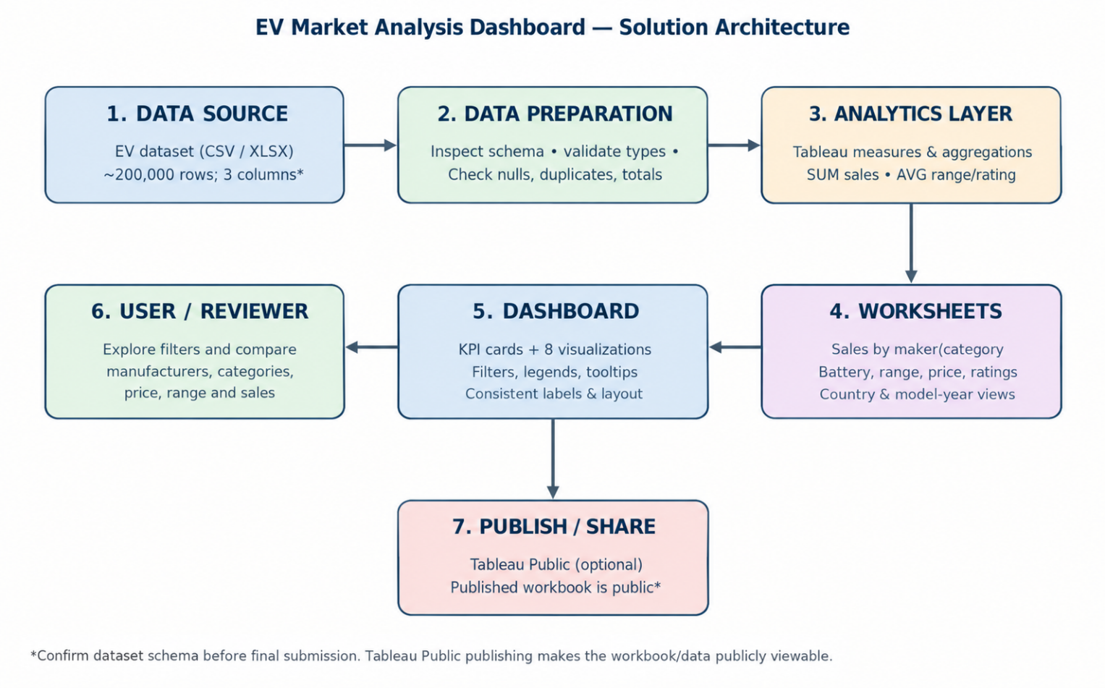

Data flow: EV dataset → data validation/preparation → Tableau measures → individual worksheets → interactive dashboard → user exploration and optional Tableau Public sharing.
Component Name | Description/Role in Architecture | Technology Used
Data source | Stores input EV market records and attributes. | CSV/XLSX dataset
Data validation | Checks column names, data types, missing values, duplicates and unusual values. | Spreadsheet checks; optional pandas/NumPy
Data preparation | Keeps fields analysis-ready and documents cleaning decisions. | Tableau Data Source / spreadsheet
Analytics layer | Aggregates measures for comparisons and KPIs. | Tableau: SUM(sales), AVG(range), AVG(rating), counts
Visualization worksheets | Answers focused business questions using individual charts. | Bar, pie/treemap, scatter, geographic and year/category charts
Dashboard interface | Combines KPI cards and charts with filters and tooltips. | Tableau dashboard, filters, legends
End user | Interprets market patterns and compares segments. | Student, reviewer, or business analyst
Publishing and access | Shares the dashboard for review when required. | Tableau Public; published workbooks are public

